# ParkLife Report – Sensor Noticeboard

Version 0.2A

The Sensor Noticeboard was not a pre-conceived idea but arose as a concept following consultation with the park stakeholders on the issues they raised and their resultant needs for data capture.

The requirements for information to be presented about sensing taking place within the public parks; the need for standalone sensor operation – in particular the supply of sufficient power to enable continuous sensing and remote monitoring; and the desire to collect data from park goers that requires individual informed consent, resulted in a digital noticeboard concept that had the potential to provide all these elements in a single and relatively easy to deploy and durable package.

A first prototype Sensor Noticeboard was built in spring 2019 to test the overall package design, and the subsequent four deployed boards to each of the parks were constructed in summer 2019. The design utilises existing off the shelf components. The core consists of a standard outdoor wall mountable A1 noticeboard with a lockable front plastic screen, a 100W solar panel as used typically in caravans and boat applications, a solar power charge controller and 20AH car battery and a custom built wood frame with hinged lockable access panel on the back for mounting and containing all the components. The Noticeboard requires basic wood working skills and workshop equipment to construct.

The photographs below show all of the Sensor Noticeboard components trialled during the ParkLife project.

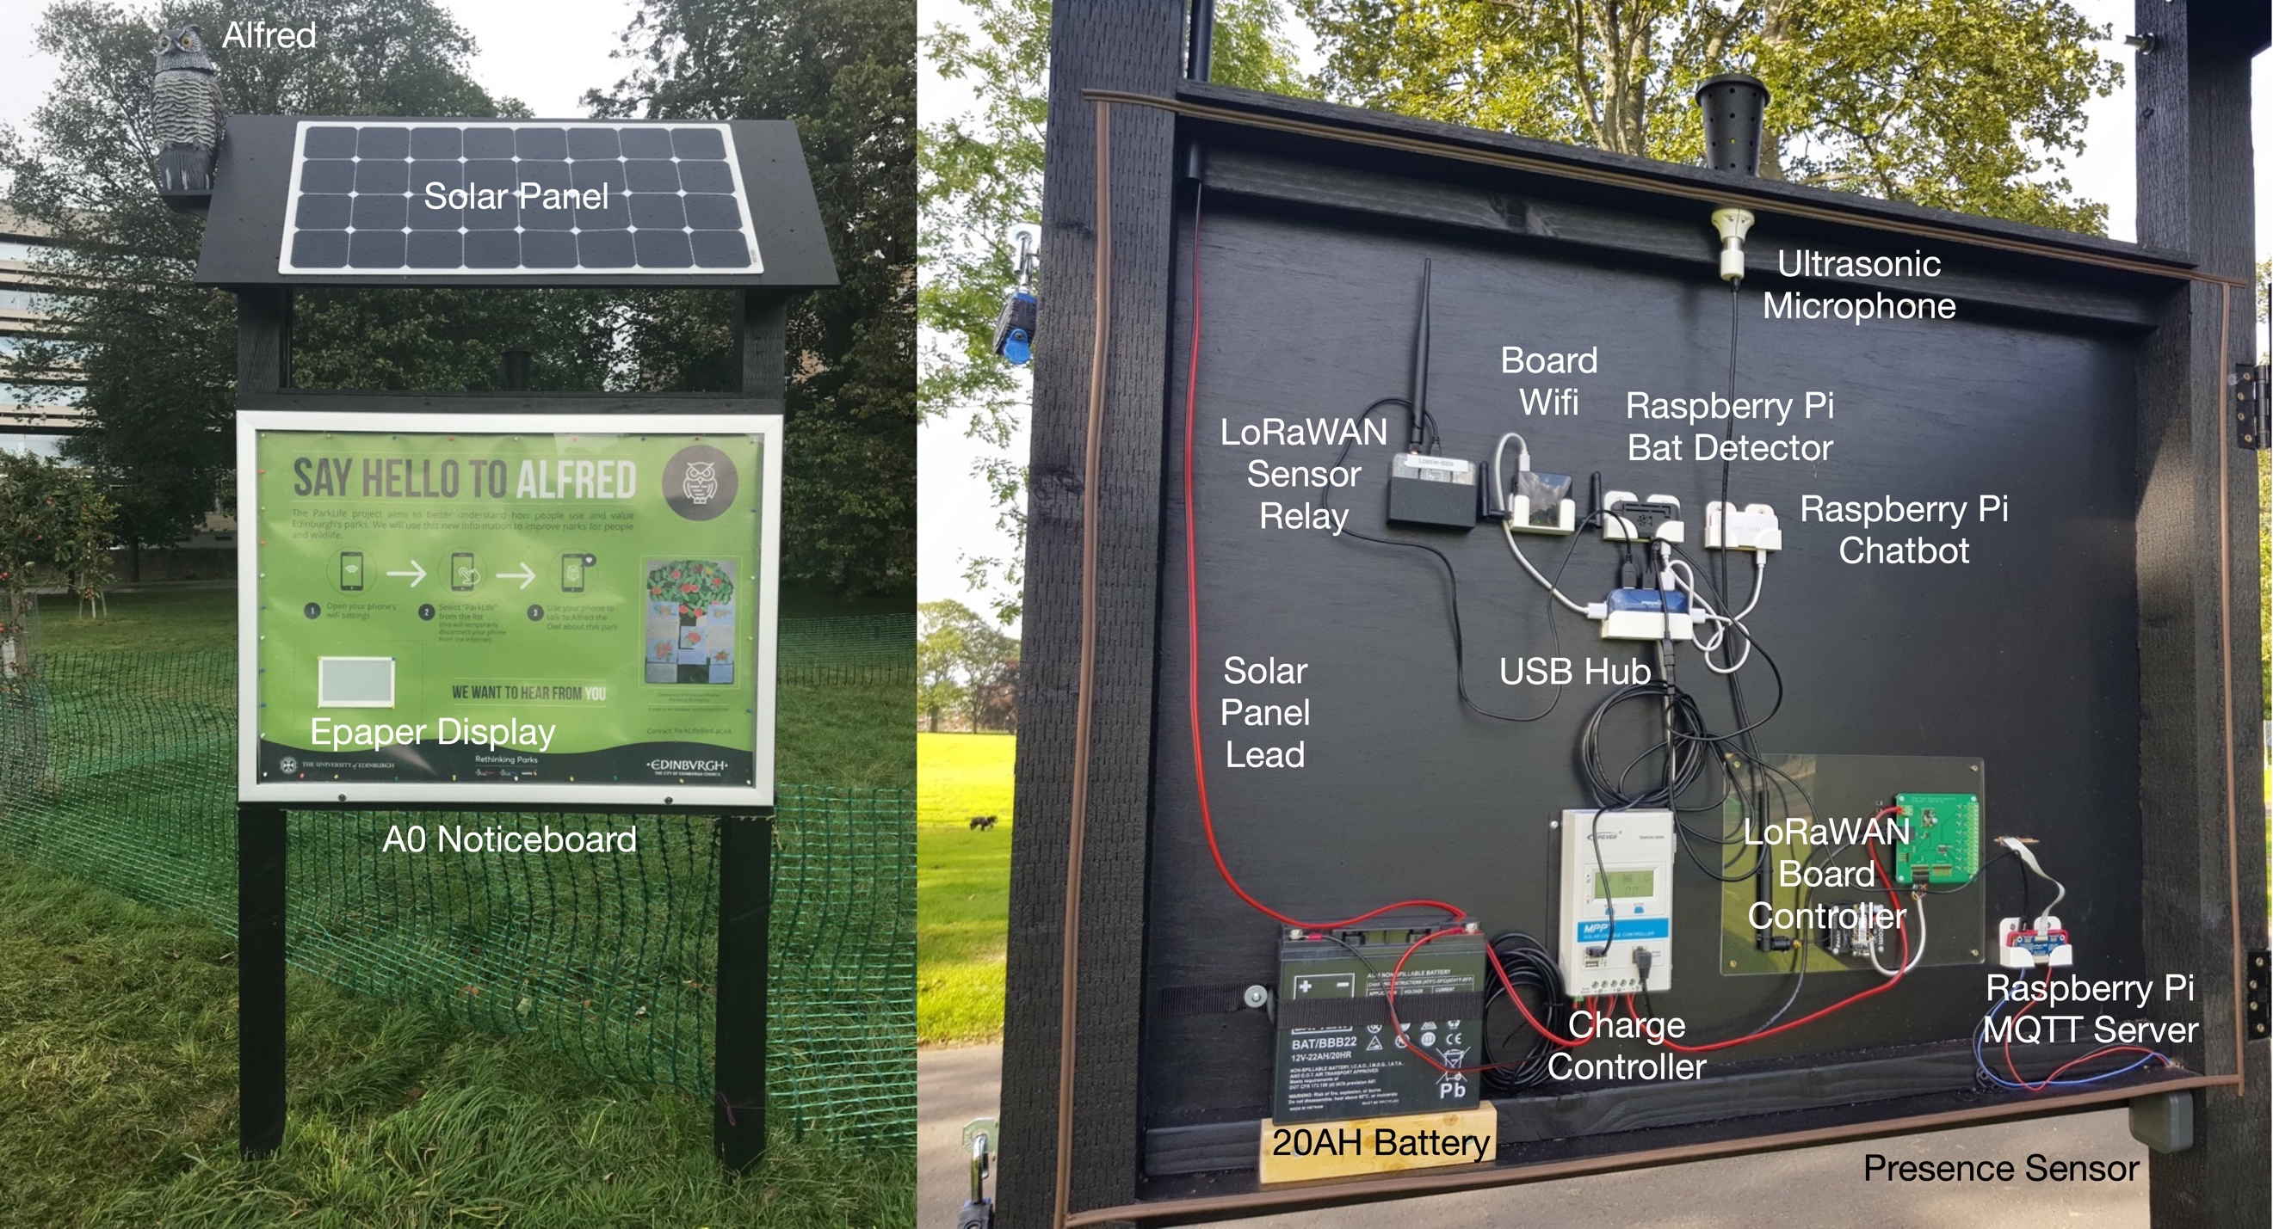

The resultant Sensor Noticeboard prototype we built and tested encapsulates these unique characteristics:

* A new physical asset within the park in a familiar format that can host a variety of sensing as well as signage (posters) and digital interaction (Epaper display and Wifi hotspot website).
* An extensible standalone sensor hub, incorporating solar power and wireless communication connectivity without the requirement for any additional infrastructure such as power lines or broadband cabling.

The ideal location for installing the Sensor Noticeboard in a park is beside a popular walking/cycling path that is not obscured by trees, but remains close to insect friendly habitat. It is best installed facing due north or due south – the solar panel can be placed in one of two orientations to ensure it faces due south for maximum solar gain. The path-side location ensures that the sensors for people and cycle detection can be utilised effectively, where the sensor range extends out from the board across the path for up to 10 metres. The proximity to insect friendly habitat increases the likelihood of bat detection – the range of ultrasonic bat detection is typically limited to around a 40 metre radius. The popularity of the pathway location also increases the amount and validity of data being captured in relation to indicating the overall activity levels of the park.

## Core Noticeboard Components

For detailed technical design and component specifications of the Sensor Noticeboard and how to access all of the software we developed for the project, please refer to the Technical Appendix of this report – the following is a high level technical summary of the core componentry.

The Sensor Noticeboard design enabled easy testing and evaluation of a wide range of sensors and interaction mechanisms for the parks. We deployed off the shelf components within the large back space (100mm deep) of the Sensor Noticeboard largely based on the low power Raspberry Pi Zero W with our own custom code. The wooden frame of the board allows easy modification for sensor protrusion whilst protecting componentry from the weather and maintaining its physical security, and being made of wood also does not cause faraday cage effects for RF communications unlike metal. The hinged back plate of the board makes contact with weather-proofing seals (brown trim in the photo above) when closed and is locked in place with padlocks.

Whilst power is self-contained within the Noticeboard, the wireless connectivity relies on additional networking infrastructure. In Edinburgh we are able to make use of a dedicated Low Power Wide Area Network (LPWAN) provided by the University of Edinburgh based on LoRaWAN. In the UK and Europe, LoRaWAN utilises the ISM free radio 868MHz band and can achieve 20km range for a radio transmission requiring only very small amounts of energy. It is ideally suited to IoT sensor applications that transmit small amounts of data every few minutes. LoRaWAN is overseen by a large collaboration of organisations through the LoRa Alliance, and has gained significant traction over the last couple of years thanks to the development of an open volunteer community built free-to-use infrastructure implementation of LoRaWAN, known as The Things Network, that is now present in hundreds of cities across the world.

If you are not able to access LoRaWAN in your locale, then an alternate is to utilise a mobile telco equivalent such as the new NB-IoT 5G standard currently being rolled out at the time of writing across the UK. These solutions will require a SIM card to be installed with paid monthly subscription. The technology we used in our Noticeboards for LoRaWAN communication was based on the Pycom LoPy development board. An alternate Pycom FiPy development board adds NB-IoT capability and can therefore be used as a drop-in replacement.

The internal board system architecture we developed included a dedicated onboard Wifi for sensor to sensor only communications using the MQTT protocol and summary information compiled and sent by the LoRaWAN Relay unit every 5 minutes, via our dedicated LoRaWAN network to our central data server hosted at the University of Edinburgh, to enable real-time remote monitoring. The Charge Controller manages the flow of power from the solar panel to recharge the battery and is monitored by the Board Controller for power generation and battery temperature and consumption levels, which then sends this information, separately from the summary sensor data, every 5 minutes. This information is important to help us understand the power profile of all the equipment on the board and that the system is working correctly.

The graph below shows the daily cycle of peak solar power generation across the four Sensor Noticeboards in each of the parks during late summer. It is interesting to observe that the Meadows Noticeboard, depicted by the green line, registers some solar panel voltage during the night period which is due to a street lamp positioned close by.

The Board Controller contains logic for the control of power consumption by the various sensing components and has the capability to turn off sensors when power levels are low.

### The Bat Detector

The Bat Detector is implemented with a USB connected Ultrasonic capable microphone and a Raspberry Pi Zero W. The microphone we used is the Ultramic192K (cost around £200). It has a frequency response in the range 0-96KHz and incorporates an analog to digital converter to produce a digital audio signal. It presents as a standard USB microphone device to the host operating system making it easy to work with. Sound frequencies above 20KHz are considered to be ultrasonic, i.e. above the range of normal human hearing. UK bat species, such as the more commonly occurring pipistrelles, do not routinely generate frequencies in their echolocation above 70KHz, and therefore this microphone is appropriate for our use in bat detection. Bats are generally most active during dusk and dawn and from Spring through to Autumn, hibernating during the cold winter months when insect prey is scarce.

Below are two frequency spectrograms of bats detected in two of the parks by our system. Each sample is just 0.2 seconds in length. The calls occupy the 40-70KHz frequency range and exhibit the classic hockey stick shape of the pipistrelle bat call associated with hunting insect prey.

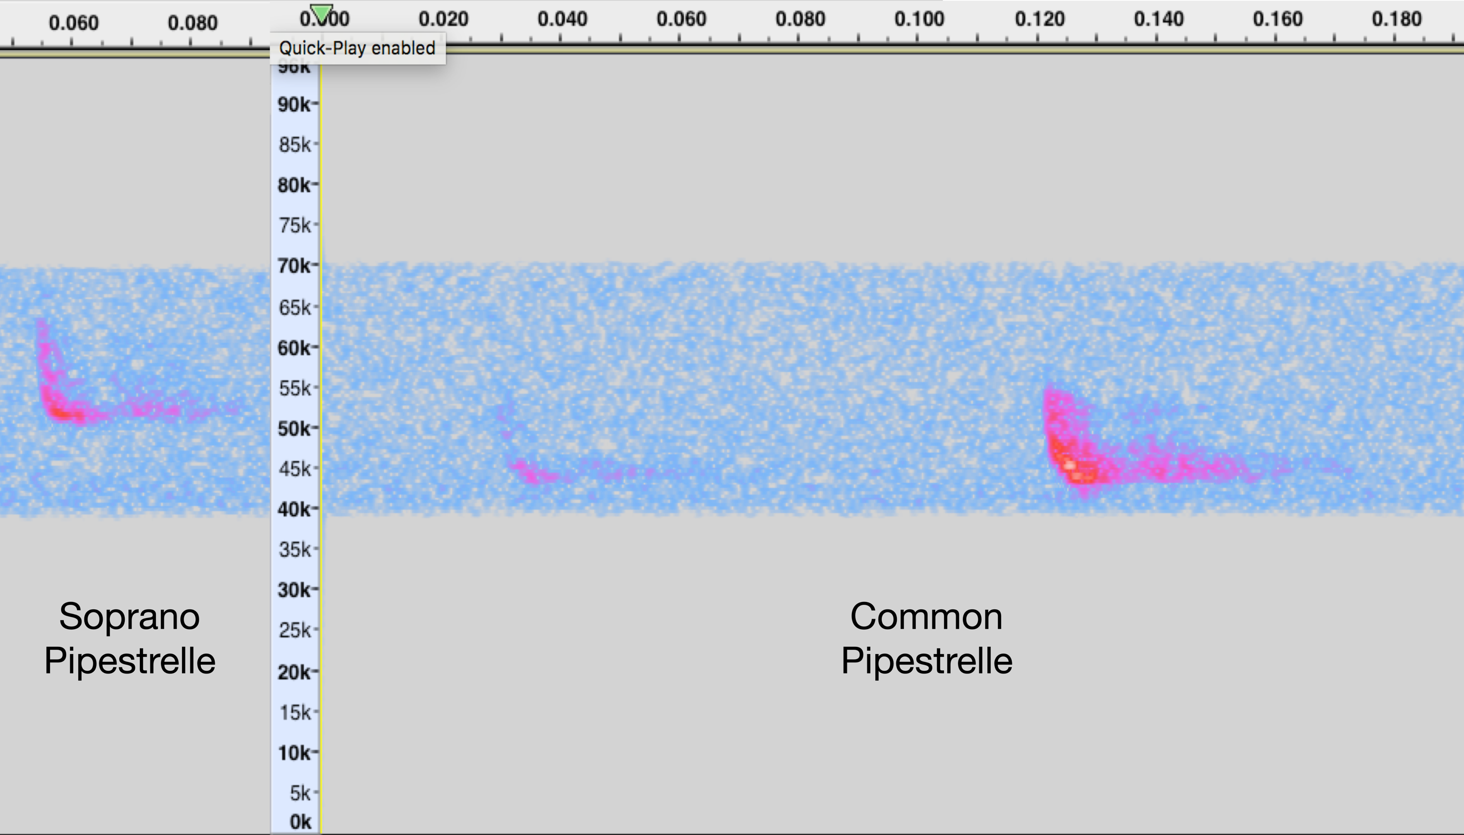

We implemented a simple form of continuous sound analysis on the Raspberry Pi Zero W to detect the bats. A sound sample of 0.2 seconds is captured from the microphone and a Fast Fourier Transform applied. The resultant sound frequency/energy time matrix is then analysed to identify a strong peak signal in the target range 40-70KHz with the appropriate time span that is indicative of a bat call. Significant testing was carried out at a private nature site elsewhere in Scotland where significant bat activity is easy to observe in order to fine tune the parameters for this algorithm. The algorithm processing on the Pi Zero W takes approximately 6 seconds to apply to a 0.2 second sample. In essence this means that the system is able to detect a bat that is echolocating and stays within microphone range for at least 6 seconds. Detections are counted over a 5-minute period and the cumulative result transmitted over LoRaWAN to the University server.

## The Presence Sensor

The first implementation of presence sensor we deployed was based on a very cheap (£1 per unit) and simple radar component, commonly used to detect presence in rooms to trigger automated lighting and similar to components used in some car bumper sensors. However, whilst this tested well in our indoors lab, we found it too unreliable when deployed into our noticeboards outdoors registering many spurious detections.

Our second and successful implementation utilises an Infra-Red LIDAR type sensor (cost around £50) which can reliably measure the distance from 0.1 to >10m to an object within its narrow field of view. The specific unit we deployed also proved reliable even when the sensor was bathed in intense sunlight.

The sensing must be tuned for distance range on each Noticeboard deployed to ensure a detection is registered for a reflected object present only within the area of the path in front of the Noticeboard, i.e. to detect passers-by, rather than those standing directly in front of the Noticeboard for a period of time. The Presence Sensor is an accurate proximity sensor that has the key advantage of operating from a single point directly attached to the Noticeboard, rather than requiring a beam break style separate emitter and receiver placed on either side of a path which would require significant additional kit to be installed including the disruptive laying of wiring under the path itself.

The Presence Sensor counts the number of triggers during each 5-minute period. This data is then sent as part of the summary information from the Noticeboard over LoRaWAN to the University central server. The graph below shows the variation in footfall during a single weekday for the Sensor Noticeboard deployed to the Meadows park. Note how there are specific peaks around 9am in the morning, lunchtime and early evening, which is consistent with people on their way and to and from their workplace.

In the latter stages of the project we were able to develop a variation on this sensing by using a pair of the Infra-Red LIDARs and a custom algorithm to detect the speed of the object passing by, enabling us to differentiate between people moving at walking-pace and cyclists who typically pass by at least twice as fast.

## The EPaper Display

One of the interaction components we implemented on the Sensor Noticeboard was a digital display based on EPaper, similar to the type of display found in digital book readers such as the Amazon Kindle. Unlike LCD or LED based display panels, EPaper and EInk displays consume very little power, essentially only requiring a small amount of energy when changing the rendered information they show. To maintain their display they consume no energy; the rendered image will remain stable for many weeks before needing an additional powered refresh cycle. However, this type of display technology is still maturing and remains expensive for single large sized area screen.

We deployed a relatively low cost small size 7” monochrome EPaper display to test its applicability in our context. On this display we showed the previous days count of People and Bats detected by the sensors on the Noticeboard – see image below.

We found that the display would not update reliably and is not designed to operate within the full glare of the sun, which in our experience has the effect of making the image fade rapidly. For a north facing Noticeboard this issue would be less of a problem.